The Raven and the Fox by Jean de La Fontaine
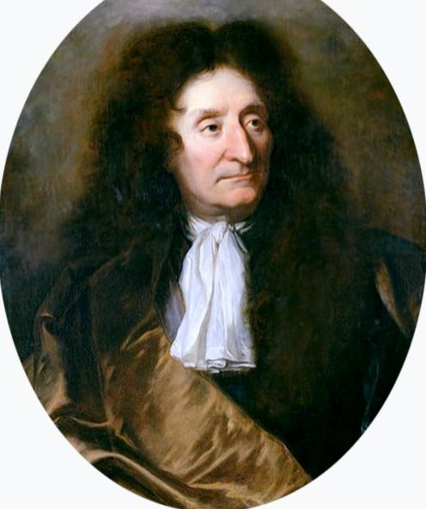
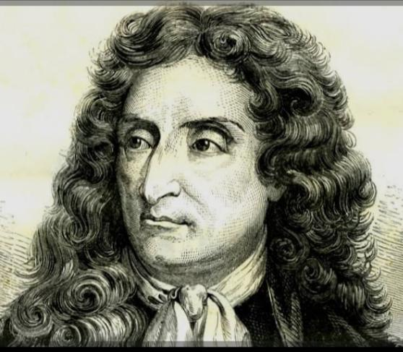
Jean de La Fontaine 8 July 1621 – 13 April 1695) was a French fabulist and one of the most widely read French poets of the 17th century. He is known above all for his Fables, which provided a model for subsequent fabulists across Europe and numerous alternative versions in France, as well as in French regional languages. After a long period of royal suspicion, he was admitted to the Académie Française and his reputation in France has never faded since. Evidence of this is found in the many pictures and statues of the writer, later depictions on medals, coins and postage stamps.

Central Idea:
The poem highlights how flattery can be deceptive, and how pride can lead to one's downfall. The fox flatters the raven to trick him into dropping his food.
Theme:
1. Deception through flattery
2. Foolishness of pride
3. Cunning vs. naivety
4. Moral lessons in animal fables
Poetic Devices:
1. Personification – Animals (Raven and Fox) talk and behave like humans.
2. Imagery– Descriptive language like "handsome bird," "great big beak," and "sweet words" paints clear pictures.
Rhyming Scheme:
The poem follows a rhyming couplet pattern: AABB throughout. For example:

limb / him (A)
beak / seek (B)
word / bird (A)
sing / King (B)
Short Answer Type Questions (30–40 words each):
1. Who are the two characters in the poem, and what is the Raven holding?
Hint: The two characters are Mr. Raven and Reynard the Fox. The Raven is holding a tasty morsel in his beak that the Fox desires.
2. What trick does the Fox play on the Raven?
Hint: The Fox flatters the Raven by praising his appearance and suggesting he would be king if he could sing, tricking the Raven into opening his beak and dropping the food.
3. How does the Raven react to the Fox’s praise?
Hint: The Raven is flattered and proud. Forgetting his voice is a croak, he opens his beak to sing, unintentionally dropping the morsel.
4. What lesson does the Fox convey at the end of the poem?
Hint: The Fox teaches that one should not be swayed by flattering words and that pride can lead to foolish mistakes.
5. What quality of the Raven leads to his loss?
Hint : The Raven’s pride and vanity make him fall for the Fox’s trick, causing him to lose the morsel.
6. What moral lesson can children learn from this poem?
Hint: Children can learn not to be misled by flattery and to remain humble. Pride can cloud judgment and lead to loss or embarrassment.
7. How can the message of the poem help us in real-life situations?
Hint: The poem reminds us to be cautious of people who may use sweet words to deceive us. It emphasizes critical thinking and the value of humility in decision-making.

